COMPLETE FINANCIAL DATABASE MANAGEMENT SYSTEM

SQL PROJECT
-- QUESTION 1: NORMALIZED DATABASE DESIGN
/* -------------------- 1. CUSTOMERS TABLE -------------------- */
CREATE TABLE Customers (
Customer_ID INT PRIMARY KEY,
Customer_Name VARCHAR(100) NOT NULL,
Email VARCHAR(100) UNIQUE,
Phone VARCHAR(15),
City VARCHAR(50)
);
/* -------------------- 2. ACCOUNTS TABLE -------------------- */
CREATE TABLE Accounts (
Account_ID INT PRIMARY KEY,
Customer_ID INT NOT NULL,
Account_Type VARCHAR(30) NOT NULL,
Opening_Balance DECIMAL(12,2) DEFAULT 0,
FOREIGN KEY (Customer_ID) REFERENCES Customers(Customer_ID)
);

/* -------------------- 3. ORDERS TABLE -------------------- */
CREATE TABLE Orders (
Order_ID INT PRIMARY KEY,
Customer_ID INT NOT NULL,
Order_Date DATE NOT NULL,
Order_Amount DECIMAL(12,2) NOT NULL,
FOREIGN KEY (Customer_ID) REFERENCES Customers(Customer_ID)
);
/* -------------------- 4. INVOICES TABLE -------------------- */
CREATE TABLE Invoices (
Invoice_ID INT PRIMARY KEY,
Order_ID INT NOT NULL,
Invoice_Date DATE NOT NULL,
Due_Date DATE NOT NULL,
Invoice_Amount DECIMAL(12,2) NOT NULL,
FOREIGN KEY (Order_ID) REFERENCES Orders(Order_ID)
);

/* -------------------- 5. PAYMENTS TABLE -------------------- */
CREATE TABLE Payments (
Payment_ID INT PRIMARY KEY,
Invoice_ID INT NOT NULL,
Payment_Date DATE NOT NULL,
Payment_Amount DECIMAL(12,2) NOT NULL,
Payment_Method VARCHAR(30),
FOREIGN KEY (Invoice_ID) REFERENCES Invoices(Invoice_ID)
);

/* -------------------- 6. EXPENSES TABLE -------------------- */
CREATE TABLE Expenses (
Expense_ID INT PRIMARY KEY,
Expense_Date DATE NOT NULL,
Category VARCHAR(50) NOT NULL,
Description VARCHAR(150),
Amount DECIMAL(12,2) NOT NULL
);

/* -------------------- 7. LEDGER TABLE -------------------- */
CREATE TABLE Ledger (
Ledger_ID INT PRIMARY KEY,
Account_ID INT NOT NULL,
Transaction_Date DATE NOT NULL,
Transaction_Type VARCHAR(20) NOT NULL,
Debit DECIMAL(12,2) DEFAULT 0,
Credit DECIMAL(12,2) DEFAULT 0,
Description VARCHAR(150),
FOREIGN KEY (Account_ID) REFERENCES Accounts(Account_ID)
);

/*====================INSERT DATA====================*/
INSERT INTO Customers VALUES
(1, 'Meera Finance', 'meera.finance@gmail.com', '9823456710', 'Udupi'),
(2, 'Devika Traders', 'devika.traders@gmail.com', '9823456711', 'Mysuru'),
(3, 'Nivan Technologies', 'nivan.tech@gmail.com', '9823456712', 'Mangaluru'),
(4, 'Aarohi Retail', 'aarohi.retail@gmail.com', '9823456713', 'Bengaluru'),
(5, 'Vihaan Services', 'vihaan.services@gmail.com', '9823456714', 'Kochi');

INSERT INTO Accounts VALUES
(1001, 1, 'Current', 72000),
(1002, 2, 'Current', 58000),
(1003, 3, 'Savings', 46500),
(1004, 4, 'Current', 83000),
(1005, 5, 'Savings', 39000);

INSERT INTO Orders VALUES
(201, 1, '2026-01-07', 68000),
(202, 2, '2026-01-19', 54000),
(203, 3, '2026-02-11', 88000),
(204, 4, '2026-03-08', 47000),
(205, 5, '2026-04-16', 62000);

INSERT INTO Invoices VALUES
(301, 201, '2026-01-07', '2026-01-27', 68000),
(302, 202, '2026-01-19', '2026-02-08', 54000),
(303, 203, '2026-02-11', '2026-03-03', 88000),
(304, 204, '2026-03-08', '2026-03-28', 47000),
(305, 205, '2026-04-16', '2026-05-06', 62000);

INSERT INTO Payments VALUES
(401, 301, '2026-01-21', 68000, 'Bank Transfer'),
(402, 302, '2026-02-02', 30000, 'UPI'),
(403, 303, '2026-02-27', 50000, 'Card'),
(404, 304, '2026-03-22', 47000, 'Bank Transfer'),
(405, 305, '2026-04-29', 25000, 'UPI');

INSERT INTO Expenses VALUES
(501, '2026-01-11', 'Rent', 'Branch office rent', 18000),
(502, '2026-02-14', 'Salary', 'Staff payroll', 36000),
(503, '2026-03-09', 'Utilities', 'Electricity and internet', 9500),
(504, '2026-04-13', 'Marketing', 'Online promotion', 14500),
(505, '2026-05-17', 'Travel', 'Client travel', 8200);

INSERT INTO Ledger VALUES
(601, 1001, '2026-01-07', 'Sales', 0, 68000, 'Corporate sale'),
(602, 1002, '2026-01-19', 'Sales', 0, 54000, 'Retail sale'),
(603, 1003, '2026-02-11', 'Sales', 0, 88000, 'Technology service'),
(604, 1004, '2026-03-08', 'Sales', 0, 47000, 'Retail order'),
(605, 1005, '2026-04-16', 'Sales', 0, 62000, 'Service contract'),
(606, 1001, '2026-02-14', 'Expense', 36000, 0, 'Salary expense');
SELECT * FROM customers;
Output:
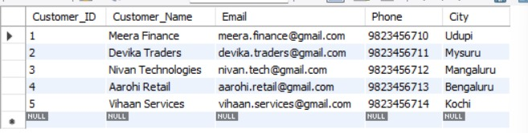
SELECT * FROM accounts;
Output:
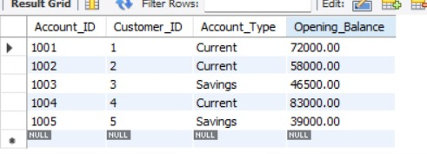
SELECT * FROM orders;
Output:
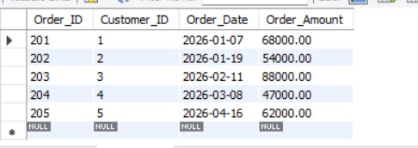
SELECT * FROM Invoices;
Output:
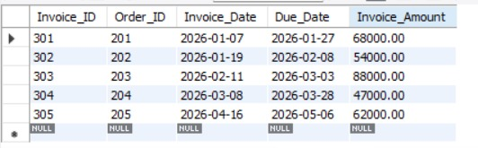
SELECT * FROM Payments;
Output:
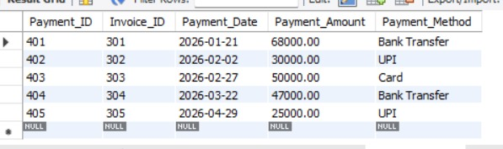
SELECT * FROM Expenses;
Output:
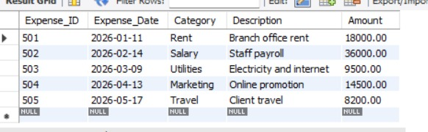
SELECT * FROM Ledger;
Output:
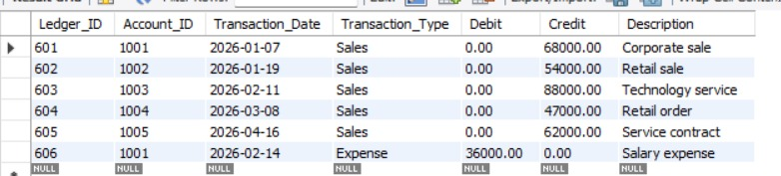

-- QUESTION 2: BASIC SQL QUERIES
CREATE TABLE basic_financial_queries (
transaction_id INT PRIMARY KEY,
customer_name VARCHAR(100),
transaction_type VARCHAR(30),
transaction_date DATE,
amount DECIMAL(12,2),
department VARCHAR(50)
);

INSERT INTO basic_financial_queries VALUES
(1,'Meera Finance','Income','2026-01-07',68000,'Sales'),
(2,'Devika Traders','Income','2026-01-19',54000,'Sales'),
(3,'Nivan Technologies','Expense','2026-02-14',36000,'HR'),
(4,'Aarohi Retail','Income','2026-03-08',47000,'Sales'),
(5,'Vihaan Services','Expense','2026-04-13',14500,'Marketing'),
(6,'Tara Enterprises','Income','2026-05-09',79000,'Sales'),
(7,'Meera Finance','Expense','2026-05-17',8200,'Travel'),
(8,'Devika Traders','Income','2026-06-15',61000,'Sales');

-- 2.1 Display all records
SELECT * FROM basic_financial_queries;

OUTPUT:
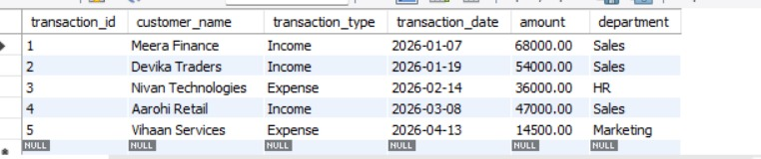

-- 2.2 Income transactions
SELECT *
FROM basic_financial_queries
WHERE transaction_type='Income';
OUTPUT:
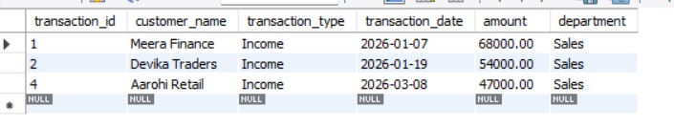

-- 2.3 Transactions above 50000
SELECT *
FROM basic_financial_queries
WHERE amount > 50000;
OUTPUT:
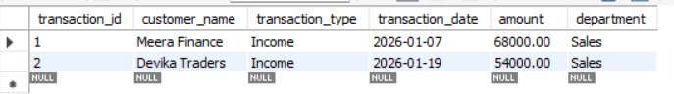

-- 2.4 Transactions between two dates
SELECT *
FROM basic_financial_queries
WHERE transaction_date BETWEEN '2026-01-01' AND '2026-03-31';
OUTPUT:
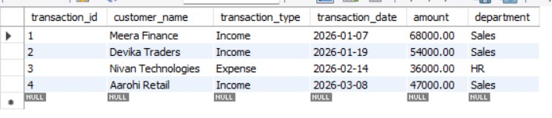

-- 2.5 Sorting by amount
SELECT *
FROM basic_financial_queries
ORDER BY amount DESC;
OUTPUT:
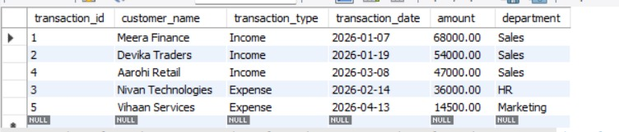

-- 2.6 GROUP BY summary
SELECT
department,
COUNT(*) AS transaction_count,
SUM(amount) AS total_amount,
ROUND(AVG(amount),2) AS average_amount
FROM basic_financial_queries
GROUP BY department;
OUTPUT:
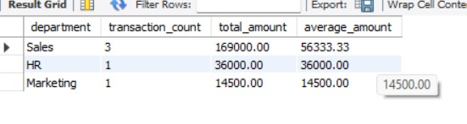

-- 2.7 CASE expression
SELECT
transaction_id,
customer_name,
amount,
CASE
WHEN amount >= 70000 THEN 'High'
WHEN amount >= 30000 THEN 'Medium'
ELSE 'Low'
END AS transaction_category
FROM basic_financial_queries;
OUTPUT:
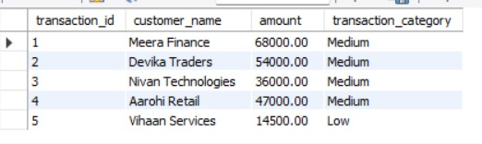

-- QUESTION 3: JOIN OPERATIONS
CREATE TABLE customer_join_table (
customer_id INT PRIMARY KEY,
customer_name VARCHAR(100),
city VARCHAR(50)
);

CREATE TABLE sales_join_table (
sale_id INT PRIMARY KEY,
customer_id INT,
sale_date DATE,
product VARCHAR(100),
amount DECIMAL(12,2)
);

INSERT INTO customer_join_table VALUES
(1,'Meera Finance','Udupi'),
(2,'Devika Traders','Mysuru'),
(3,'Nivan Technologies','Mangaluru'),
(4,'Aarohi Retail','Bengaluru'),
(5,'Vihaan Services','Kochi'),
(6,'Tara Enterprises','Pune');

INSERT INTO sales_join_table VALUES
(201,1,'2026-01-07','Cloud Subscription',68000),
(202,2,'2026-01-19','POS Equipment',26000),
(203,1,'2026-02-12','Network Devices',34000),
(204,3,'2026-03-08','ERP License',88000),
(205,4,'2026-04-20','Barcode Systems',12000),
(206,5,'2026-05-09','Consulting Package',62000);

SELECT * FROM customer_join_table;
OUTPUT:
CUSTOMER_JOIN_TABLE
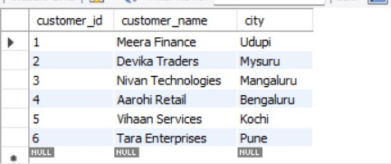

SELECT * FROM sales_join_table;
SALES_JOIN_TABLE
OUTPUT:

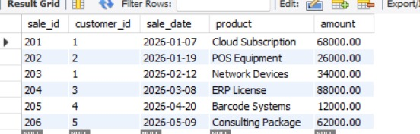

-- 3.1 INNER JOIN
SELECT
c.customer_id,
c.customer_name,
c.city,
s.sale_id,
s.product,
s.amount
FROM customer_join_table c
INNER JOIN sales_join_table s
ON c.customer_id=s.customer_id;
OUTPUT:
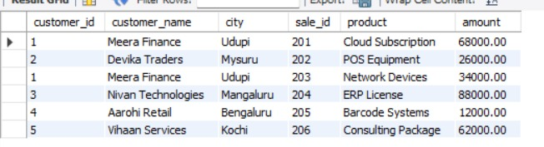

-- 3.2 LEFT JOIN
SELECT
c.customer_id,
c.customer_name,
s.sale_id,
s.amount
FROM customer_join_table c
LEFT JOIN sales_join_table s
ON c.customer_id=s.customer_id;
OUTPUT:
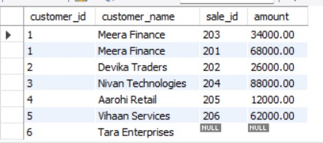

-- 3.3 RIGHT JOIN
SELECT
c.customer_id,
c.customer_name,
s.sale_id,
s.amount
FROM customer_join_table c
RIGHT JOIN sales_join_table s
ON c.customer_id=s.customer_id;
OUTPUT:
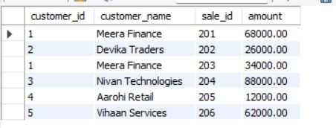
-- 3.4 JOIN + GROUP BY
SELECT
c.customer_id,
c.customer_name,
COALESCE(SUM(s.amount),0) AS total_sales
FROM customer_join_table c
LEFT JOIN sales_join_table s
ON c.customer_id=s.customer_id
GROUP BY c.customer_id,c.customer_name;
OUTPUT:

-- 3.5 Multiple-table JOIN
SELECT
c.customer_name,
o.order_id,
o.order_amount,
i.invoice_id,
i.invoice_amount,
p.payment_id,
p.payment_amount
FROM customers c
JOIN orders o
ON c.customer_id=o.customer_id
JOIN invoices i
ON o.order_id=i.order_id
LEFT JOIN payments p
ON i.invoice_id=p.invoice_id;
OUTPUT:
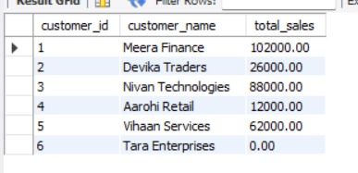
-- QUESTION 4: VIEWS
CREATE TABLE customer_view_table (
customer_id INT PRIMARY KEY,
customer_name VARCHAR(100),
city VARCHAR(50)
);

CREATE TABLE invoice_view_table (
invoice_id INT PRIMARY KEY,
customer_id INT,
invoice_amount DECIMAL(12,2),
due_date DATE
);

CREATE TABLE payment_view_table (
payment_id INT PRIMARY KEY,
invoice_id INT,
payment_amount DECIMAL(12,2),
payment_date DATE
);

INSERT INTO customer_view_table VALUES
(1,'Meera Finance','Udupi'),
(2,'Devika Traders','Mysuru'),
(3,'Nivan Technologies','Mangaluru'),
(4,'Aarohi Retail','Bengaluru'),
(5,'Vihaan Services','Kochi'),
(6,'Tara Enterprises','Pune');

INSERT INTO invoice_view_table VALUES
(501,1,68000,'2026-01-27'),
(502,2,54000,'2026-02-08'),
(503,3,88000,'2026-03-03'),
(504,4,47000,'2026-03-28'),
(505,5,62000,'2026-05-06'),
(506,6,79000,'2026-05-29');

INSERT INTO payment_view_table VALUES
(601,501,68000,'2026-01-21'),
(602,502,30000,'2026-02-02'),
(603,503,50000,'2026-02-27'),
(604,504,47000,'2026-03-22'),
(605,505,25000,'2026-04-29'),
(606,506,79000,'2026-05-24');

Select * from customer_view_table;
OUTPUT:
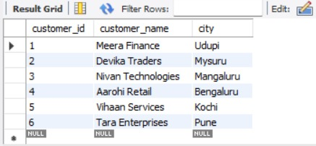
Select * from invoice_view_table;
OUTPUT:
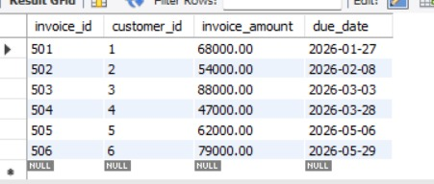
Select * from payment_view_table;
OUTPUT:
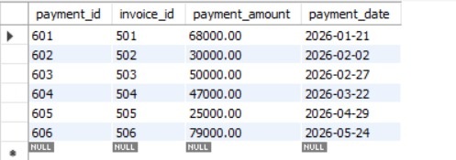

CREATE OR REPLACE VIEW customer_balance_view AS
SELECT
c.customer_id,
c.customer_name,
i.invoice_id,
i.invoice_amount,
COALESCE(SUM(p.payment_amount),0) AS paid_amount,
i.invoice_amount-COALESCE(SUM(p.payment_amount),0) AS balance
FROM customer_view_table c
JOIN invoice_view_table i
ON c.customer_id=i.customer_id
LEFT JOIN payment_view_table p
ON i.invoice_id=p.invoice_id
GROUP BY
c.customer_id,c.customer_name,
i.invoice_id,i.invoice_amount;

SELECT * FROM customer_balance_view;
OUTPUT:
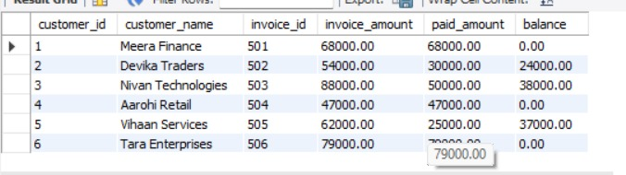

CREATE OR REPLACE VIEW overdue_balance_view AS
SELECT
customer_id,
customer_name,
invoice_id,
invoice_amount,
paid_amount,
balance
FROM customer_balance_view
WHERE balance > 0;

SELECT * FROM overdue_balance_view;
OUTPUT:
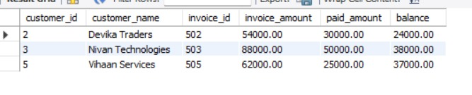
-- QUESTION 5: SUBQUERIES
CREATE TABLE customer_subquery_table (
customer_id INT PRIMARY KEY,
customer_name VARCHAR(100),
city VARCHAR(50),
total_sales DECIMAL(12,2)
);

INSERT INTO customer_subquery_table VALUES
(1,'Meera Finance','Udupi',132000),
(2,'Devika Traders','Mysuru',115000),
(3,'Nivan Technologies','Mangaluru',154000),
(4,'Aarohi Retail','Bengaluru',69000),
(5,'Vihaan Services','Kochi',97000),
(6,'Tara Enterprises','Pune',141000);

SELECT * FROM customer_subquery_table;
OUTPUT:
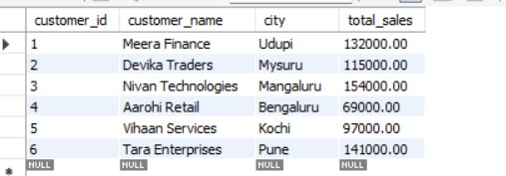

-- 5.1 Customers with sales greater than average sales
SELECT *
FROM customer_subquery_table
WHERE total_sales >
(SELECT AVG(total_sales)
FROM customer_subquery_table);
OUTPUT:
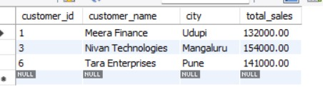

-- 5.2 Customer with maximum sales
SELECT *
FROM customer_subquery_table
WHERE total_sales =
(SELECT MAX(total_sales)
FROM customer_subquery_table);
OUTPUT:
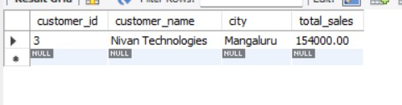

-- 5.3 Customers whose sales are above Meera Finance's sales
SELECT *
FROM customer_subquery_table
WHERE total_sales >
(SELECT total_sales
FROM customer_subquery_table
WHERE customer_name='Meera Finance');
OUTPUT:
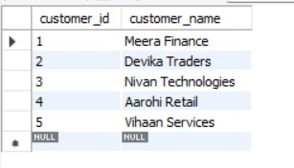

-- 5.4 Correlated subquery
SELECT
c1.customer_name,
c1.city,
c1.total_sales
FROM customer_subquery_table c1
WHERE c1.total_sales >
(SELECT AVG(c2.total_sales)
FROM customer_subquery_table c2
WHERE c2.city=c1.city);
OUTPUT:
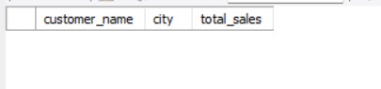

-- 5.5 EXISTS subquery
SELECT
c.customer_id,
c.customer_name
FROM customer_subquery_table c
WHERE EXISTS (
SELECT 1
FROM orders o
WHERE o.customer_id=c.customer_id
);
OUTPUT:

-- QUESTION 6: CTE

CREATE TABLE customer_cte_table (
customer_id INT PRIMARY KEY,
customer_name VARCHAR(100),
month_name VARCHAR(20),
sales DECIMAL(12,2),
expenses DECIMAL(12,2)
);

INSERT INTO customer_cte_table VALUES
(1,'Meera Finance','January',62000,27000),
(2,'Meera Finance','February',71000,31000),
(3,'Meera Finance','March',68000,29000),
(4,'Devika Traders','January',55000,24000),
(5,'Devika Traders','February',63000,28000),
(6,'Devika Traders','March',72000,32000),
(7,'Nivan Technologies','January',81000,39000),
(8,'Nivan Technologies','February',86000,41000),
(9,'Nivan Technologies','March',92000,44000);

SELECT * FROM customer_cte_table;
OUTPUT:
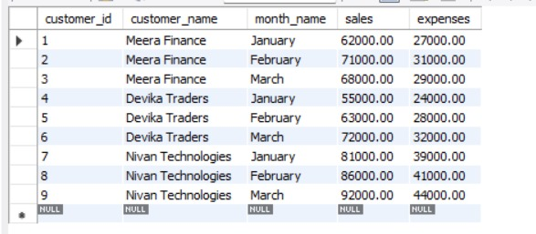

-- 6.1 CTE for profit
WITH customer_profit_cte AS (
SELECT
customer_id,
customer_name,
month_name,
sales,
expenses,
sales-expenses AS profit
FROM customer_cte_table
)
SELECT *
FROM customer_profit_cte
ORDER BY profit DESC;
OUTPUT:
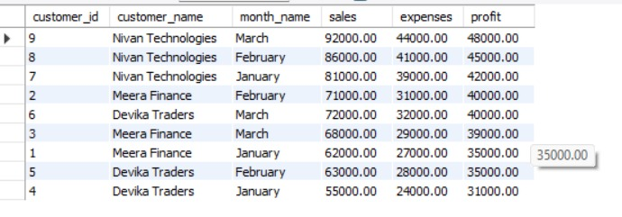
-- 6.2 CTE + GROUP BY
WITH customer_summary_cte AS (
SELECT
customer_id,
customer_name,
SUM(sales) AS total_sales,
SUM(expenses) AS total_expenses
FROM customer_cte_table
GROUP BY customer_id,customer_name
)
SELECT
customer_id,
customer_name,
total_sales,
total_expenses,
total_sales-total_expenses AS total_profit
FROM customer_summary_cte
ORDER BY total_profit DESC;

-- 6.3 Multiple CTEs
WITH sales_cte AS (
SELECT
customer_id,
SUM(sales) AS total_sales
FROM customer_cte_table
GROUP BY customer_id
),
expense_cte AS (
SELECT
customer_id,
SUM(expenses) AS total_expenses
FROM customer_cte_table
GROUP BY customer_id
)
OUTPUT:
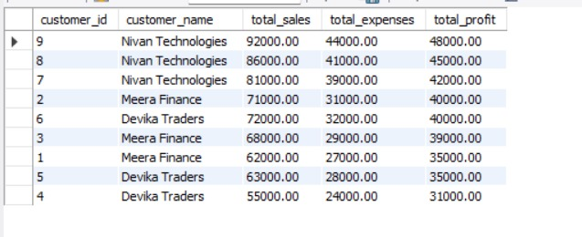

SELECT
s.customer_id,
c.customer_name,
s.total_sales,
e.total_expenses,
s.total_sales-e.total_expenses AS profit
FROM sales_cte s
JOIN expense_cte e
ON s.customer_id=e.customer_id
JOIN normalized_customers c
ON s.customer_id=c.customer_id;
OUTPUT:
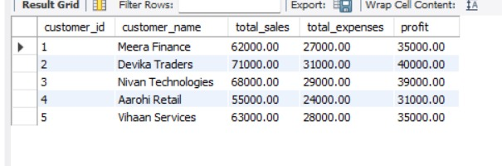

-- QUESTION 7: WINDOW FUNCTIONS
CREATE TABLE customer_window_table (
sale_month DATE,
customer_name VARCHAR(50),
sales DECIMAL(12,2)
);

INSERT INTO customer_window_table
(sale_month,customer_name,sales)
VALUES
('2025-01-01','Meera',108000),
('2025-02-01','Devika',121000),
('2025-03-01','Meera',116000),
('2025-04-01','Aarohi',145000),
('2025-05-01','Devika',133000),
('2025-06-01','Meera',139000),
('2025-07-01','Aarohi',152000),
('2025-08-01','Devika',161000),
('2025-09-01','Meera',147000),
('2025-10-01','Aarohi',174000),
('2025-11-01','Devika',168000),
('2025-12-01','Meera',159000),
('2026-01-01','Meera',136000),
('2026-02-01','Devika',149000),
('2026-03-01','Meera',151000),
('2026-04-01','Aarohi',178000),
('2026-05-01','Devika',164000),
('2026-06-01','Meera',163000),
('2026-07-01','Aarohi',186000),
('2026-08-01','Devika',179000),
('2026-09-01','Meera',171000),
('2026-10-01','Aarohi',195000),
('2026-11-01','Devika',188000),
('2026-12-01','Meera',182000);

SELECT * FROM customer_window_table;
OUTPUT:
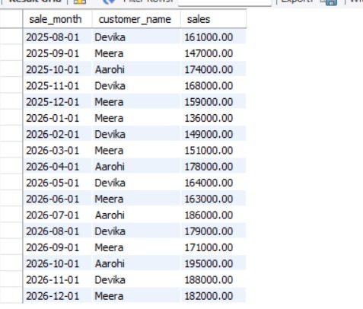

-- 7.1 RANK
SELECT
sale_month,
customer_name,
sales,
RANK() OVER (ORDER BY sales DESC) AS sales_rank
FROM customer_window_table;
OUTPUT:
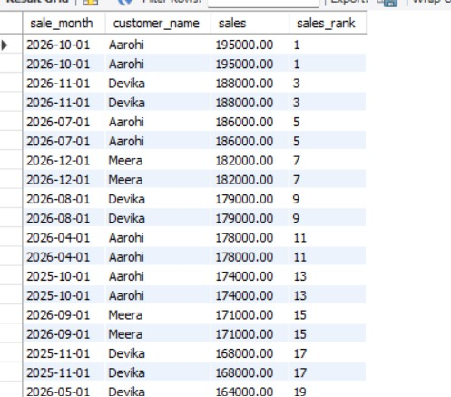

-- 7.2 DENSE_RANK
SELECT
sale_month,
customer_name,
sales,
DENSE_RANK() OVER (ORDER BY sales DESC) AS sales_rank
FROM customer_window_table;
OUTPUT:
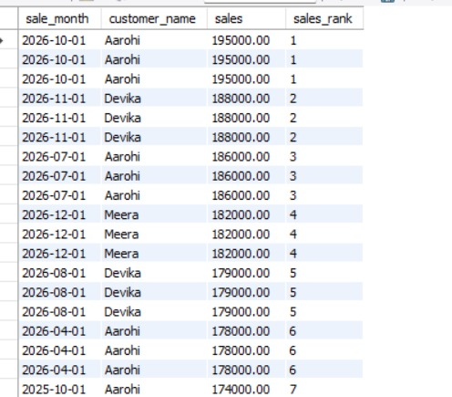

-- 7.3 ROW_NUMBER
SELECT
sale_month,
customer_name,
sales,
ROW_NUMBER() OVER (ORDER BY sales DESC) AS row_number_of_sales
FROM customer_window_table;
OUTPUT:

-- 7.4 Previous Month Sales using LAG
SELECT
sale_month,
customer_name,
sales,
LAG(sales) OVER (ORDER BY sale_month) AS previous_month_sales
FROM customer_window_table;
OUTPUT:

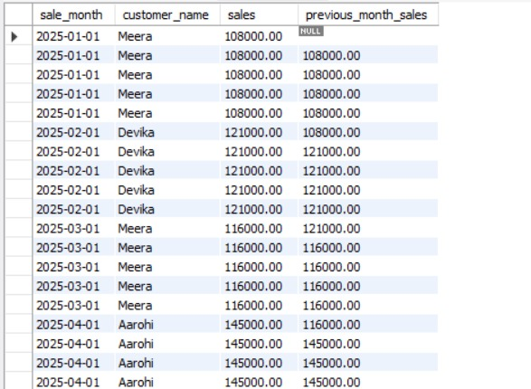

-- 7.5 Next Month Sales using LEAD
SELECT
sale_month,
customer_name,
sales,
LEAD(sales) OVER (ORDER BY sale_month) AS next_month_sales
FROM customer_window_table;
OUTPUT:

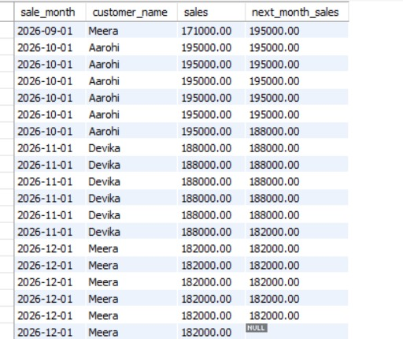

-- 7.6 Previous Year Sales using LAG
SELECT
sale_month,
customer_name,
sales,
LAG(sales,12) OVER (ORDER BY sale_month) AS previous_year_sales
FROM customer_window_table;
OUTPUT:

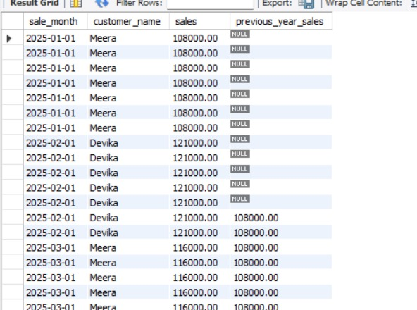

-- 7.7 Next Year Sales using LEAD
SELECT
sale_month,
customer_name,
sales,
LEAD(sales,12) OVER (ORDER BY sale_month) AS next_year_sales
FROM customer_window_table;
OUTPUT:

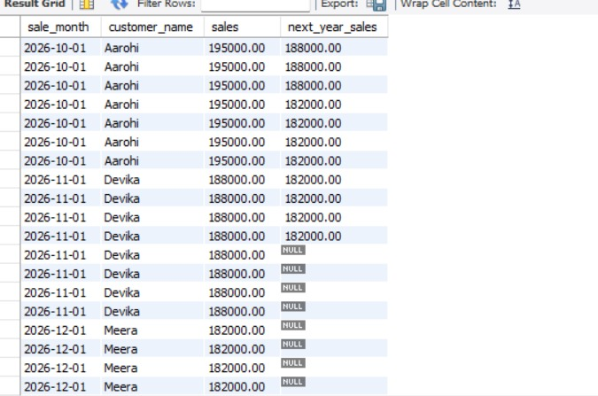

-- 7.8 Running Total of Sales
SELECT
sale_month,
customer_name,
sales,
SUM(sales) OVER (
ORDER BY sale_month
ROWS BETWEEN UNBOUNDED PRECEDING AND CURRENT ROW
) AS running_total
FROM customer_window_table;
OUTPUT:

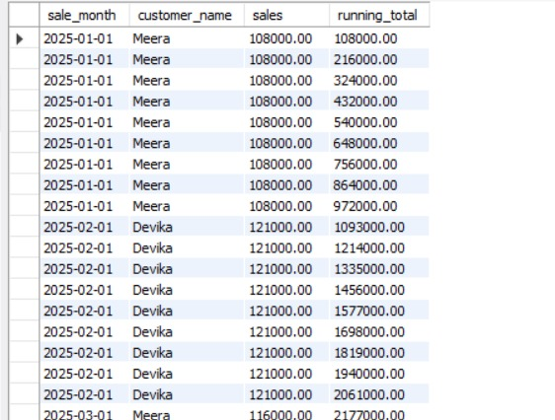

-- 7.9 Year-over-Year Growth
WITH yearly_sales AS (
SELECT
sale_month,
customer_name,
sales,
LAG(sales,12) OVER (ORDER BY sale_month) AS previous_year_sales
FROM customer_window_table
)
SELECT
sale_month,
customer_name,
sales,
previous_year_sales,
ROUND(
((sales-previous_year_sales)/NULLIF(previous_year_sales,0))*100,
2
) AS yoy_growth
FROM yearly_sales;
OUTPUT:
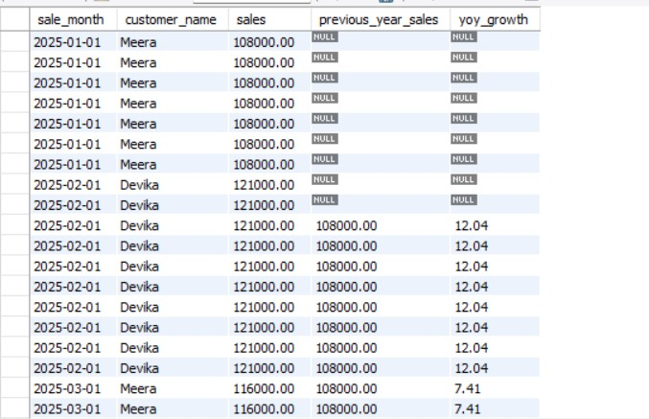

-- 7.10 All important window functions together
SELECT
sale_month,
customer_name,
sales,
RANK() OVER (ORDER BY sales DESC) AS sales_rank,
DENSE_RANK() OVER (ORDER BY sales DESC) AS sales_dense_rank,
ROW_NUMBER() OVER (ORDER BY sales DESC) AS sales_row_number,
LAG(sales) OVER (ORDER BY sale_month) AS previous_month_sales,
LEAD(sales) OVER (ORDER BY sale_month) AS next_month_sales
FROM customer_window_table;
OUTPUT:

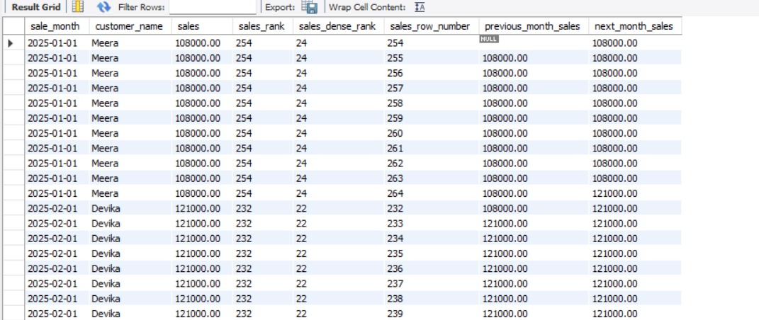

-- QUESTION 8: STORED PROCEDURES
-- Main table
CREATE TABLE financial_procedure_table (
id INT PRIMARY KEY,
customer_name VARCHAR(50),
month_name VARCHAR(20),
sales DECIMAL(10,2),
expenses DECIMAL(10,2),
tax_rate DECIMAL(5,2)
);
-- Insert values
INSERT INTO financial_procedure_table
VALUES
(1, 'Rahul', 'January', 50000, 30000, 10),
(2, 'Priya', 'January', 60000, 35000, 10),
(3, 'Anu', 'January', 45000, 25000, 10),
(4, 'Rahul', 'February', 55000, 32000, 10),
(5, 'Priya', 'February', 65000, 38000, 10),
(6, 'Anu', 'February', 50000, 27000, 10),
(7, 'Rahul', 'March', 60000, 34000, 10),
(8, 'Priya', 'March', 70000, 40000, 10),
(9, 'Anu', 'March', 55000, 30000, 10);
SELECT *
FROM financial_procedure_table;
Output:
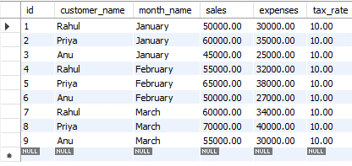
-- 8.1 TAX CALCULATION PROCEDURE
DELIMITER //
CREATE PROCEDURE calculate_tax(
IN p_sales DECIMAL(10,2),
IN p_tax_rate DECIMAL(10,2)
)
BEGIN
SELECT
p_sales AS sales,
p_tax_rate AS tax_rate,
(p_sales * p_tax_rate) / 100 AS tax_amount;
END //
DELIMITER ;
-- Test the procedure
CALL calculate_tax(50000, 3);
CALL calculate_tax(22000, 5);
Output:
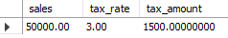
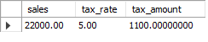
-- 8.2 MONTH-END CLOSING PROCEDURE
CREATE TABLE month_end_report_table (
month VARCHAR(30),
total_sales DECIMAL(12,2),
total_expenses DECIMAL(12,2),
profit_loss DECIMAL(12,2)
);
DELIMITER //
CREATE PROCEDURE month_end_closing(
IN p_month VARCHAR(20)
)
BEGIN
INSERT INTO month_end_report_table
(
month,
total_sales,
total_expenses,
profit_loss
)
SELECT
month_name,
SUM(sales),
SUM(expenses),
SUM(sales) - SUM(expenses)
FROM financial_procedure_table
WHERE month_name = p_month
GROUP BY month_name;
END //
DELIMITER ;
-- Test the procedure
CALL month_end_closing('March');
CALL month_end_closing('February');
SELECT *
FROM month_end_report_table;
Output:
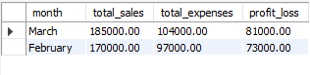
-- 8.3 CUSTOMER SUMMARY PROCEDURE
DELIMITER //
CREATE PROCEDURE customer_summary(
IN p_customer VARCHAR(50)
)
BEGIN
SELECT
customer_name,
SUM(sales) AS total_sales,
SUM(expenses) AS total_expenses,
SUM(sales) - SUM(expenses) AS total_profit
FROM financial_procedure_table
WHERE customer_name = p_customer
GROUP BY customer_name;
END //
DELIMITER ;
-- Test the procedure
CALL customer_summary('Anu');
CALL customer_summary('Priya');
Output:
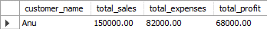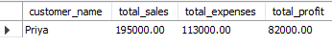
-- 8.4 YEAR-END PROFIT PROCEDURE
CREATE TABLE year_end_report_table (
total_sales DECIMAL(12,2),
total_expenses DECIMAL(12,2),
total_profit DECIMAL(12,2)
);
DELIMITER //
CREATE PROCEDURE year_end_profit()
BEGIN
INSERT INTO year_end_report_table
(
total_sales,
total_expenses,
total_profit
)
SELECT
SUM(sales),
SUM(expenses),
SUM(sales) - SUM(expenses)
FROM financial_procedure_table;
END //
DELIMITER ;
-- Test the procedure
CALL year_end_profit();
SELECT *
FROM year_end_report_table;
Output:
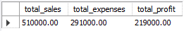
QUESTION 9: TRIGGERS
CREATE TABLE financial_trigger_table (
transaction_id INT PRIMARY KEY,
customer_name VARCHAR(100),
transaction_type VARCHAR(20),
amount DECIMAL(12,2),
transaction_date DATE
);
CREATE TABLE financial_audit_table (
audit_id INT AUTO_INCREMENT PRIMARY KEY,
transaction_id INT,
customer_name VARCHAR(100),
transaction_type VARCHAR(20),
amount DECIMAL(12,2),
action_type VARCHAR(20),
action_time TIMESTAMP DEFAULT CURRENT_TIMESTAMP
);
SELECT *
FROM financial_trigger_table;
Output:
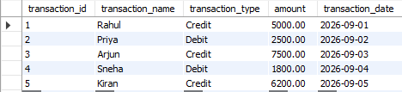
DELIMITER //
9.1 INSERT audit trigger
CREATE TRIGGER after_financial_insert
AFTER INSERT ON financial_trigger_table
FOR EACH ROW
BEGIN
INSERT INTO financial_audit_table
(transaction_id, customer_name, transaction_type,
amount, action_type)
VALUES
(NEW.transaction_id, NEW.customer_name,
NEW.transaction_type, NEW.amount, 'INSERT');
END//
Output:
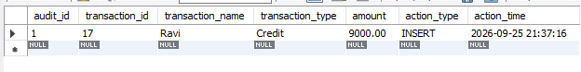
9.2 UPDATE audit trigger
CREATE TRIGGER after_financial_update
AFTER UPDATE ON financial_trigger_table
FOR EACH ROW
BEGIN
INSERT INTO financial_audit_table
(transaction_id, customer_name, transaction_type,
amount, action_type)
VALUES
(NEW.transaction_id, NEW.customer_name,
NEW.transaction_type, NEW.amount, 'UPDATE');
END//
Output:
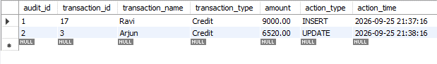
9.3 DELETE audit trigger
CREATE TRIGGER after_financial_delete
AFTER DELETE ON financial_trigger_table
FOR EACH ROW
BEGIN
INSERT INTO financial_audit_table
(transaction_id, customer_name, transaction_type,
amount, action_type)
VALUES
(OLD.transaction_id, OLD.customer_name,
OLD.transaction_type, OLD.amount, 'DELETE');
END//
DELIMITER ;
INSERT INTO financial_trigger_table VALUES
(1,'Rahul','Credit',50000,'2026-09-01'),
(2,'Priya','Debit',15000,'2026-09-02'),
(3,'Arjun','Credit',75000,'2026-09-03');
UPDATE financial_trigger_table
SET amount = 55000
WHERE transaction_id = 1;
DELETE FROM financial_trigger_table
WHERE transaction_id = 2;
Output:
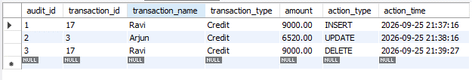
SELECT * FROM financial_trigger_table;
SELECT * FROM financial_audit_table;

-- QUESTION 10: SECURITY FEATURES
CREATE TABLE Customers_SECURITY_FEATURES (
Customer_ID INT PRIMARY KEY,
Customer_Name VARCHAR(100) NOT NULL,
Email VARCHAR(100)
);

CREATE TABLE Transactions_SECURITY_FEATURES (
Transaction_ID INT PRIMARY KEY,
Customer_ID INT,
Amount DECIMAL(10,2),
TransactionDate DATE,
FOREIGN KEY (Customer_ID)
REFERENCES Customers_SECURITY_FEATURES(Customer_ID)
);

CREATE TABLE Salaries_SECURITY_FEATURES (
Employee_ID INT PRIMARY KEY,
Employee_Name VARCHAR(100) NOT NULL,
Salary DECIMAL(10,2)
);

INSERT INTO Customers_SECURITY_FEATURES VALUES
(1,'Meera Finance','meera.finance@example.com'),
(2,'Devika Traders','devika.traders@example.com'),
(3,'Nivan Technologies','nivan.tech@example.com');

INSERT INTO Transactions_SECURITY_FEATURES VALUES
(1,1,68000,'2026-09-01'),
(2,2,54000,'2026-09-02'),
(3,3,92000,'2026-09-03');

INSERT INTO Salaries_SECURITY_FEATURES VALUES
(101,'Finance Manager',78000),
(102,'Accountant',52000),
(103,'Financial Analyst',61000);

select * from Customers_SECURITY_FEATURES;
OUTPUT:
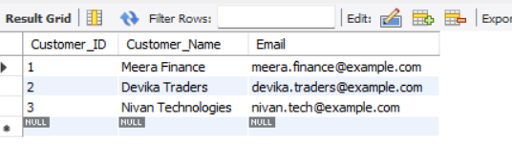
select * from Transactions_SECURITY_FEATURES;
OUTPUT:
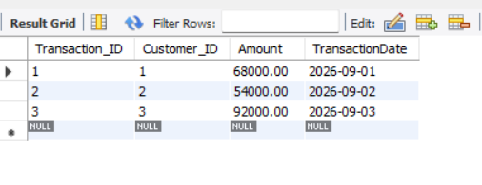
select * from Salaries_SECURITY_FEATURES;
OUTPUT:
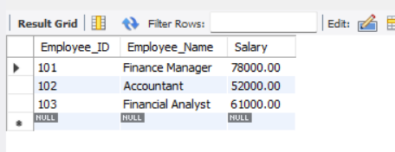
CREATE ROLE IF NOT EXISTS 'finance_report_role';

GRANT SELECT,INSERT,UPDATE
ON unique_financial_db_project.*
TO 'finance_manager_role';

GRANT SELECT
ON unique_financial_db_project.*
TO 'finance_report_role';
SHOW GRANTS FOR 'finance_manager_role';
SHOW GRANTS FOR 'finance_report_role';
OUTPUT:
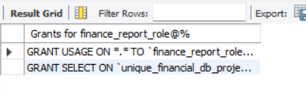
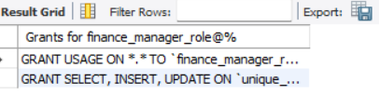

-- QUESTION 11: COMPREHENSIVE FINANCIAL REPORTING
CREATE TABLE financial_reporting_table (
report_id INT PRIMARY KEY,
customer_name VARCHAR(50),
report_date DATE,
revenue DECIMAL(12,2),
expenses DECIMAL(12,2),
tax_amount DECIMAL(12,2),
total_assets DECIMAL(12,2),
total_liabilities DECIMAL(12,2),
accounts_receivable DECIMAL(12,2),
accounts_payable DECIMAL(12,2),
net_profit DECIMAL(12,2),
profit_margin DECIMAL(6,2)
);

INSERT INTO financial_reporting_table
(report_id,customer_name,report_date,revenue,expenses,tax_amount,
total_assets,total_liabilities,accounts_receivable,accounts_payable,
net_profit,profit_margin)
VALUES
(1,'Meera Finance','2026-01-31',94000,52000,7520,
310000,98000,22000,14000,34480,36.68),
(2,'Devika Traders','2026-01-31',81000,46000,6480,
245000,82000,18000,11000,28520,35.21),
(3,'Nivan Technologies','2026-01-31',103000,57000,8240,
355000,121000,27000,17000,37760,36.66),
(4,'Meera Finance','2026-02-28',108000,59000,8640,
325000,101000,25000,15000,40360,37.37),
(5,'Devika Traders','2026-02-28',89000,49000,7120,
259000,85000,21000,12000,32880,36.94),
(6,'Nivan Technologies','2026-02-28',116000,62000,9280,
371000,126000,30000,18000,44720,38.55),
(7,'Meera Finance','2026-03-31',112000,61000,8960,
338000,106000,27000,16000,42040,37.54),
(8,'Devika Traders','2026-03-31',97000,53000,7760,
268000,89000,23000,13000,36240,37.36),
(9,'Nivan Technologies','2026-03-31',124000,66000,9920,
389000,132000,32000,19000,48080,38.77);

SELECT * FROM financial_reporting_table;
OUTPUT:
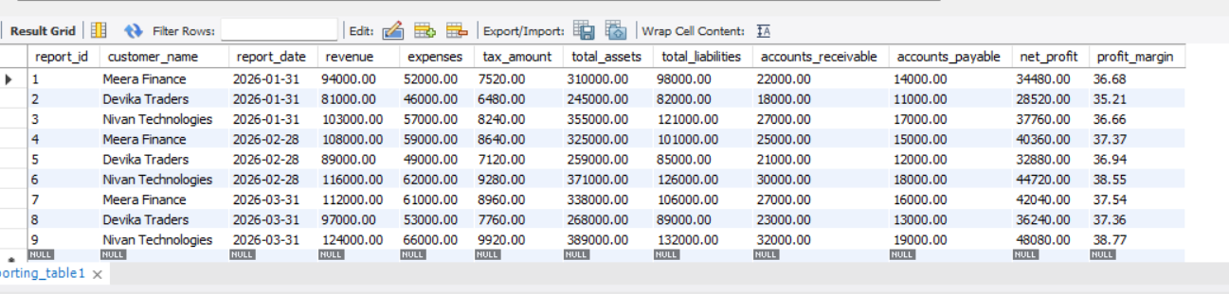

-- 11.1 Average financial performance
SELECT
ROUND(AVG(revenue),2) AS average_revenue,
ROUND(AVG(expenses),2) AS average_expenses,
ROUND(AVG(net_profit),2) AS average_net_profit,
ROUND(AVG(profit_margin),2) AS average_profit_margin
FROM financial_reporting_table;
OUTPUT:
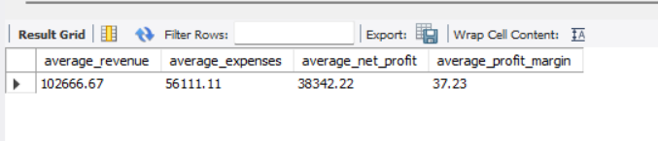

-- 11.2 Total revenue, expenses, tax and profit
SELECT
SUM(revenue) AS total_revenue,
SUM(expenses) AS total_expenses,
SUM(tax_amount) AS total_tax,
SUM(net_profit) AS total_net_profit
FROM financial_reporting_table;
OUTPUT:
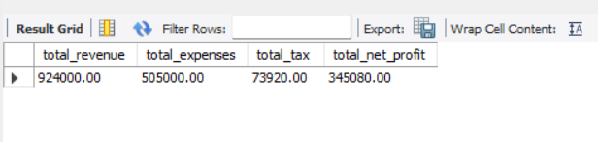

-- 11.3 Overall business financial summary
SELECT
SUM(revenue) AS total_revenue,
SUM(expenses) AS total_expenses,
SUM(tax_amount) AS total_tax,
SUM(net_profit) AS total_net_profit,
SUM(total_assets) AS total_assets,
SUM(total_liabilities) AS total_liabilities,
SUM(accounts_receivable) AS total_receivables,
SUM(accounts_payable) AS total_payables,
ROUND(
(SUM(net_profit)/NULLIF(SUM(revenue),0))*100,
2
) AS overall_profit_margin
FROM financial_reporting_table;
OUTPUT:
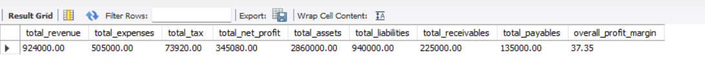

-- 11.4 Customer-wise financial performance
SELECT
customer_name,
SUM(revenue) AS revenue,
SUM(expenses) AS expenses,
SUM(net_profit) AS net_profit,
ROUND(AVG(profit_margin),2) AS average_profit_margin
FROM financial_reporting_table
GROUP BY customer_name
ORDER BY net_profit DESC;
OUTPUT:
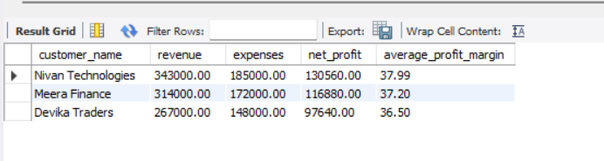

-- 11.5 Monthly financial performance
SELECT
report_date,
SUM(revenue) AS monthly_revenue,
SUM(expenses) AS monthly_expenses,
SUM(net_profit) AS monthly_profit,
ROUND(
SUM(net_profit)/NULLIF(SUM(revenue),0)*100,
2
) AS monthly_profit_margin
FROM financial_reporting_table
GROUP BY report_date
ORDER BY report_date;
OUTPUT:
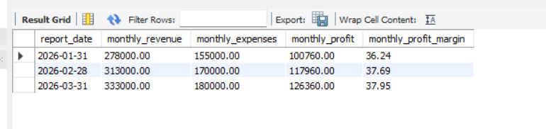
-- 11.6 Liquidity indicators
SELECT
SUM(total_assets) AS total_assets,
SUM(total_liabilities) AS total_liabilities,
SUM(accounts_receivable) AS accounts_receivable,
SUM(accounts_payable) AS accounts_payable,
ROUND(
SUM(accounts_receivable) /
NULLIF(SUM(accounts_payable),0),
2
) AS receivable_to_payable_ratio
FROM financial_reporting_table;
OUTPUT:
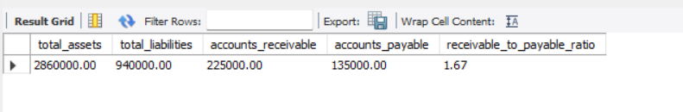

-- 11.7 Highest-revenue customer
SELECT
customer_name,
SUM(revenue) AS total_revenue
FROM financial_reporting_table
GROUP BY customer_name
ORDER BY total_revenue DESC
LIMIT 1;
OUTPUT:
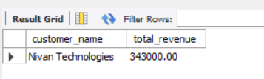

-- 11.8 Highest-profit reporting period
SELECT
report_date,
SUM(net_profit) AS total_period_profit
FROM financial_reporting_table
GROUP BY report_date
ORDER BY total_period_profit DESC
LIMIT 1;
OUTPUT:
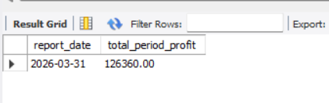

-- 11.9 Management KPI dashboard
SELECT
COUNT(DISTINCT customer_name) AS active_customers,
SUM(revenue) AS revenue,
SUM(expenses) AS expenses,
SUM(tax_amount) AS tax,
SUM(net_profit) AS net_profit,
ROUND(SUM(net_profit)/NULLIF(SUM(revenue),0)*100,2)
AS profit_margin,
SUM(accounts_receivable) AS receivables,
SUM(accounts_payable) AS payables
FROM financial_reporting_table;
OUTPUT:
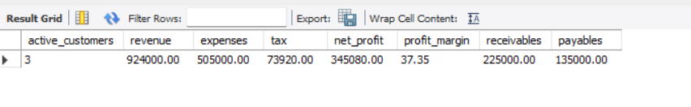
-- 11.10 Profitability classification
SELECT
customer_name,
SUM(revenue) AS revenue,
SUM(net_profit) AS net_profit,
CASE
WHEN SUM(net_profit)/NULLIF(SUM(revenue),0) >= 0.38
THEN 'Strong Margin'
WHEN SUM(net_profit)/NULLIF(SUM(revenue),0) >= 0.35
THEN 'Stable Margin'
ELSE 'Needs Review'
END AS profitability_status
FROM financial_reporting_table
GROUP BY customer_name;
OUTPUT:
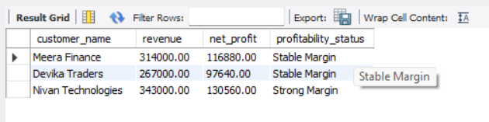

-- FINAL DATABASE CHECK
SHOW TABLES;

SELECT 'PROJECT COMPLETED SUCCESSFULLY' AS project_status;
OUTPUT:
